Creating an upgrade plan for AIQUM from version 9.10 RC1 to 9.14. This Upgrade will be on AIQUM this is installed in Centos.

Note->Performing an Active IQ Unified Manager upgrade helps to gain new features and functionality and resolves known issues. Unified Manager Upgrades are limited to an N-2 model, meaning an upgrade can only be performed within the next 2 releases.
EX: - Upgrade from AIQUM 9.10 to AIQUM 9.14 is as follows: Upgrade from 9.10 to 9.12 -> Upgrade from 9.12 to 9.14.

- We need to verify the compatibility Checks whether our current environment supports upgrading version or not.
- We can keep the backup of current AIQUM configuration and data.

Steps to upgrade Unified Manager:-

- Login to the target Centos server
- Stop all the AIQUM services to make sure that we can proceed with upgrade without any issue.

- Get the Unified Manager package for Centos and save it onto the server.
Path to download ->
- go to the https://mysupport.netapp.com
- go to download and again click on download
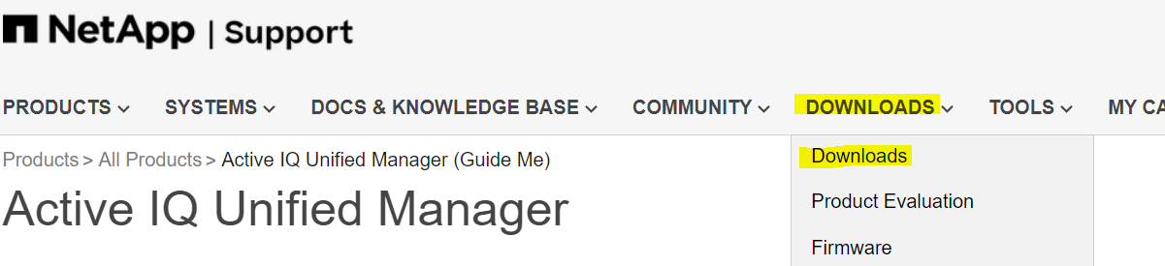
- Select Active IQ unified Manager from the downloads
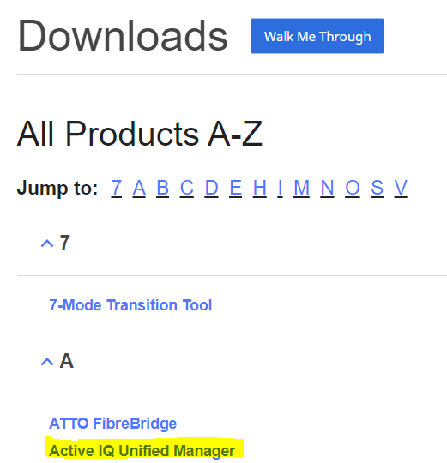
- Select the Target Versions from the dropdown and click on Go.
->Then click on Accept and Continue.
->Download the package as per the required.

Refer screenshots for reference
Example:-

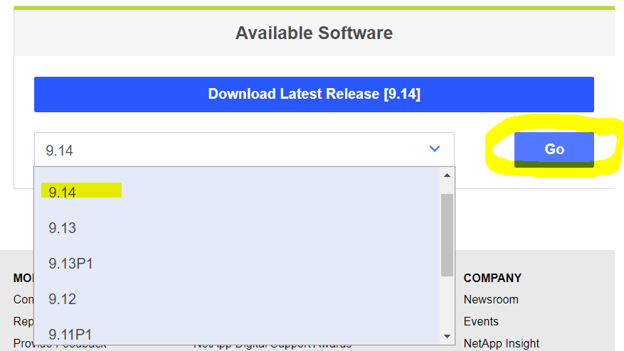

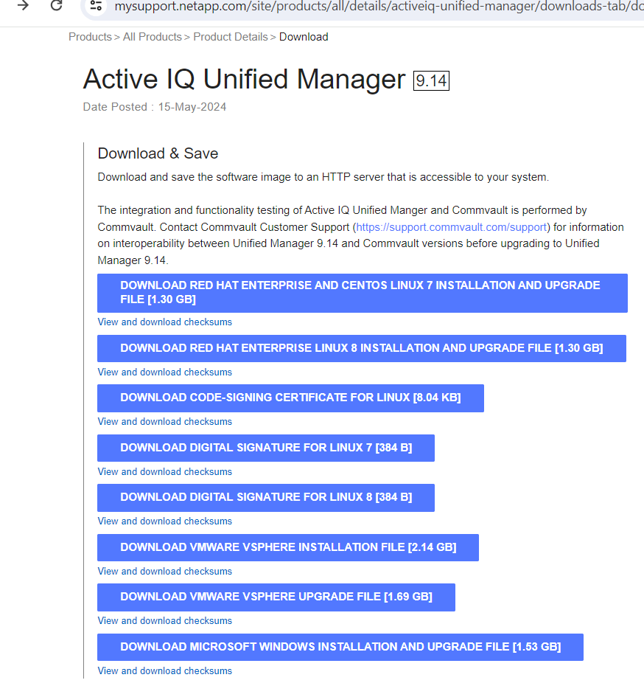

- Go to the folder where the Unified Manager package is located, and then extract the files from the package.

Script to run >
unzip ActiveIQUnifiedManager-<version>.zip

The necessary RPM(Package Manager) modules for Unified Manager have been extracted to the specified directory.

- Check if the specified module is present in the directory.
Script to run >
ls *.rpm

netapp-um<version>.x86_64.rpm

- Before installing the upgrade, run a script to check if there are any system settings or installed software that could cause problems or any software installed that might create a conflict.

Script to run ->

sudo ./pre_install_check.sh

The pre-installation script makes sure the system has a valid subscription for Red Hat Enterprise Linux and can access the necessary software repositories.

- Upgrade Unified Manager by running the provided script
Script to run ->
upgrade.sh
This script will run by itself and upgrade the required supporting software and the modules for Unified Manager.

Note: - while upgrading, we need to keep an eye on the logs and progress indicators to make sure everything is going as per planning. If we see any errors or warnings, we need to check to fix it.

- After the upgrade is finished, we will see a message pop up “Active IQ Unified Manager Upgraded successfully” for Unified Manager.

Open a new window in web browser and type web address/IP to access the Unified Manager web interface to check the system/application is working correctly. Login with credentials.

- Once the upgrade is completed restart AIQUM services. We check the functionalities of AIQUM 9.14 after upgrade.

- Enable the jobs which are disabled before upgrade and inform the user about the updated version and new feature in version 9.14.

- We need to update the document about the changes we made.

